**Introduction to Databases**

**Assignment/ Questions**

https://docs.google.com/document/d/1P1f6mWTMqFQM5DeRX8IQJ1HfOHJHxSeRXXkPeQNLs-8/edit?tab=t.0

Q1)Problem Statement: There can be multiple customers, who can place multiple orders on the site. Now a sales person can handle these orders will distribute into multiple sales persons (One order will be assign to one salesperson only). So a sales person can have multiple orders of multiple customers Create Database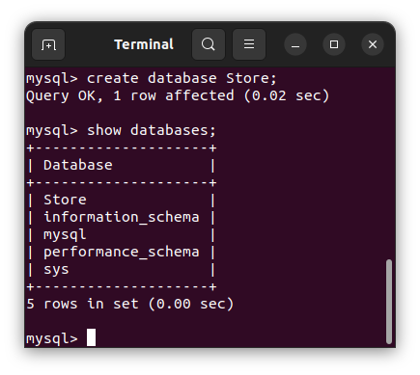

Q2)Design Schema

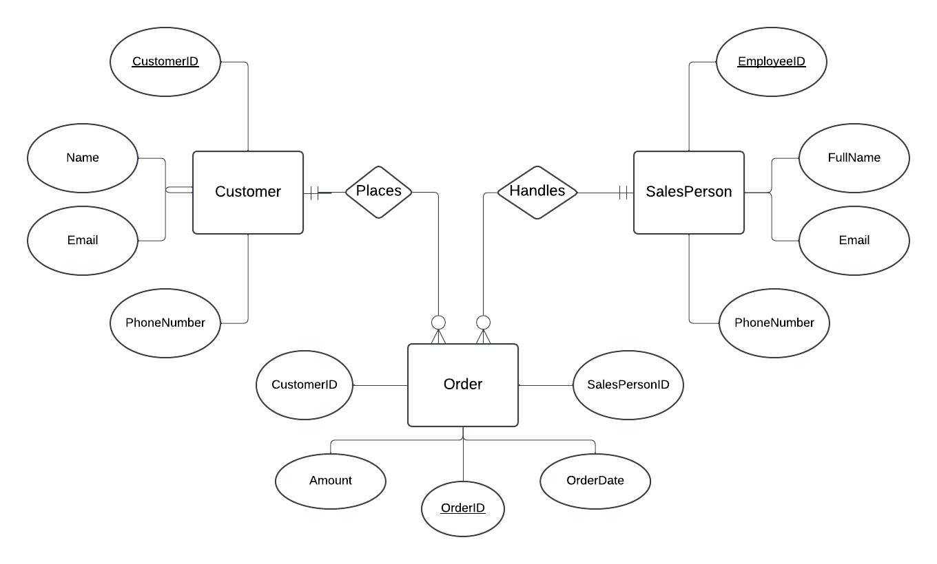

Q3)Create tables

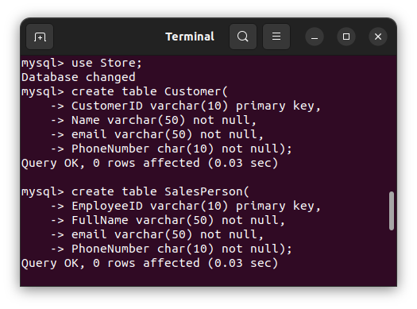

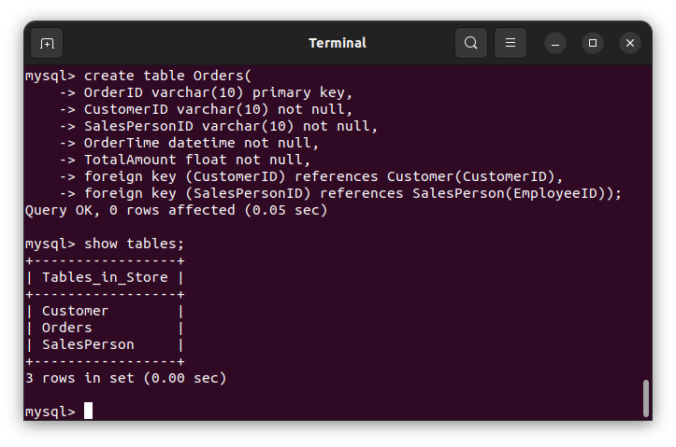

Structure of the created tables using desc:

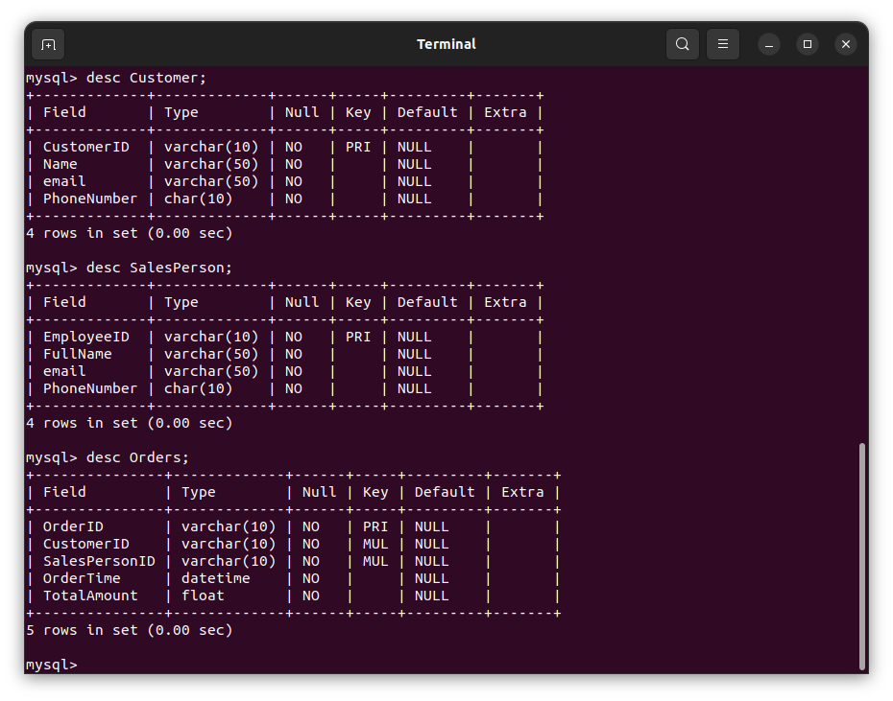

Q4)Insert sample data

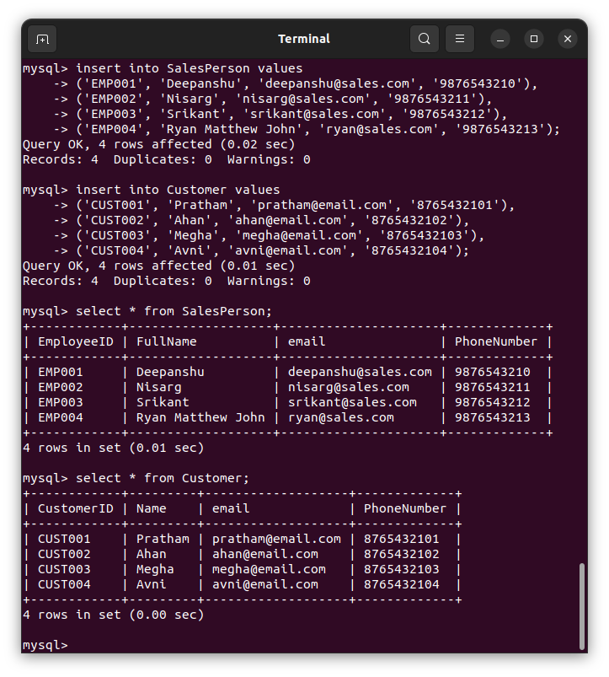

Testing Different datetime functions for Orders (current_timestamp and now() )  
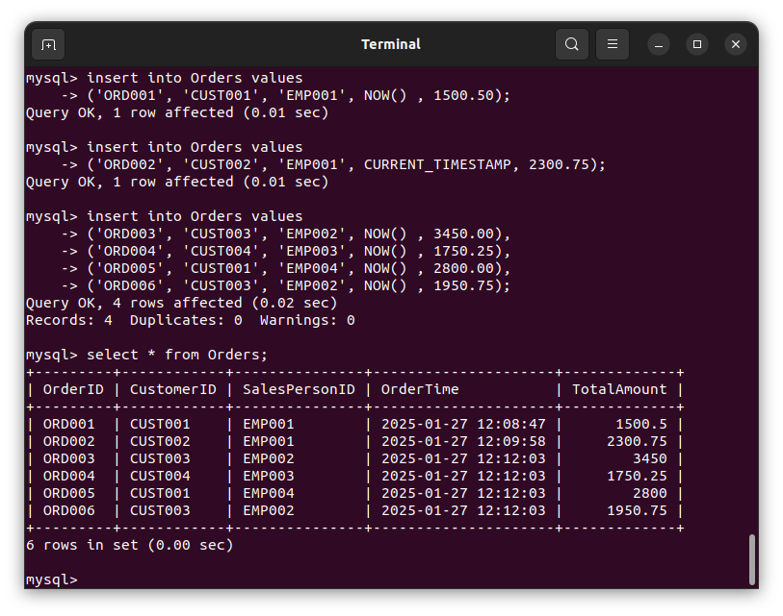

Q5)Find the sales person have multiple orders.

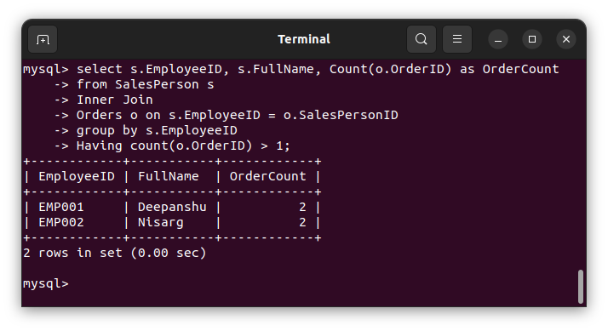

Q6)Find the all sales person details along with order details

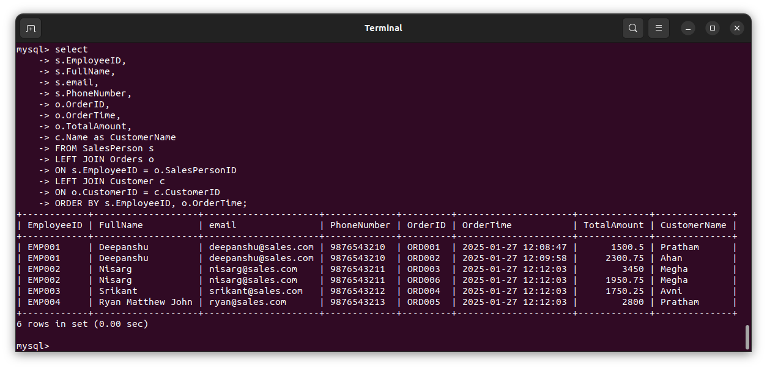

Q7)Create index

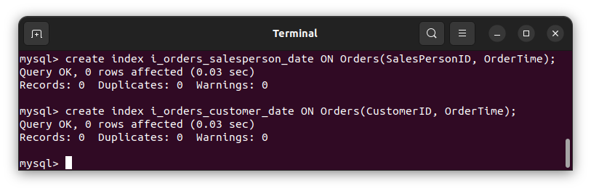

Q8)How to show index on a table

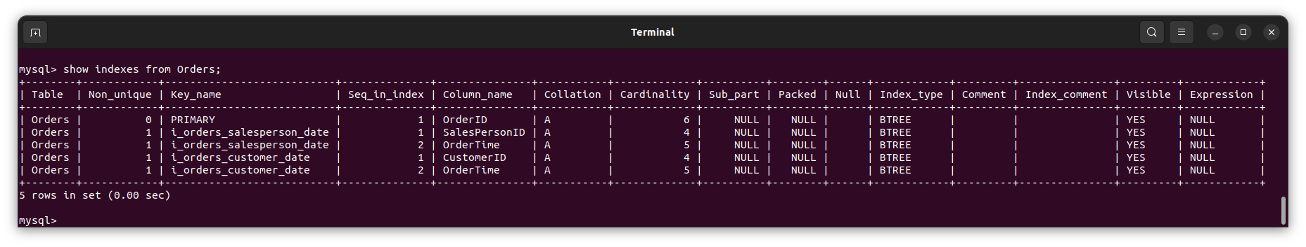

Q9)Find the order number, sale person name, along with the customer to whom that order belongs to

